**Software Requirements Specification (SRS)**

**HFDS3**

Authors:

Ryan LaHaie – Project Manager

Hannah Wood – Project Facilitator

Tony Sulfaro – Artifacts Manager

Andrew Kilponen – Security Manager

Jon Stover – Domain Expert/Customer Liaison

Customer: Andrew Davenport, General Motors AI/ML

Instructor: Dr. Cheng  
  
**1 Introduction**

This Software Requirements Specification will be covering our system, Hands-Free Driving, in detail. Within this document, the main sections include an introduction of our project, a description including the more technical details of our project, the requirements for the system as well as the modeling language used. Finally, are the references used throughout this document. This document will cover the requirements of our system in detail. Although there are little to no implementation details within this document, the requirements have been thoroughly analyzed.

**1.1 Purpose**

The purpose of this SRS document is to inform the reader of the current requirements and implications of a hands-free driving system. This document is intended for anyone who is interested in implementing such a system. Whether the reader is interested in what a hands-free driving system would look like, or interested in what structures would need to be in place for a hands-free driving system to exist, they will be discussed in this paper. However, this paper will seldom delve into implementation details, so this will only be a guide for those trying to create a hands-free driving system. The audience of this paper must also be able to understand some level of technical detail surrounding the system, as the paper discusses the way these systems interact. Although the technical jargon is kept to a minimum, there is inevitably some need for technical language.   
  
**1.2 Scope**

The software product being produced here is the Hands-Free Driving System (HFDS). The HFDS will allow the vehicle to operate on its own while the driver is attentive. This means that on approved highways, the vehicle will accelerate, decelerate, and steer on its own. The HFDS will be a system embedded within the vehicle.  While the vehicle is on an approved and mapped highway, the HFDS can be engaged in order to allow the car to operate itself with the driver monitoring the vehicle. This system will account for variances in the projected route or in the sensors by relinquishing control of the vehicle to the driver. This is important because any variance within the system could pose a security or safety risk, so control must be given back to the driver. The system will also be able to consider the behavior of other vehicles, being able to call on the adaptive cruise control in order to match the speed to the vehicles surrounding it. The HFDS will also call on the Driver Attention System to ensure that the driver is attentively monitoring the vehicle, and in the case they are not, produce audio and visual warnings to indicate that they must return attention to the vehicle. If the driver does not return their attention to the vehicle after the warnings, the vehicle may stop automatically. The system monitors the driver by using cameras to monitor eye and head placement.

This system will not work on un-mapped highways or any other type of road. It also will not operate under any conditions the system finds unfavorable such as a broken sensor. It will only take care of collision detection in that if a car ahead slows down, it will attempt to slow down to match the speed. However, if the vehicle is cut off and a collision is imminent, it will do as much as possible to mitigate the impact collision. There is no feature for setting a destination, the vehicle will continue to drive until the system is turned off.

The benefit of this system is to allow the driver to continue to stay alert while not having to operate the vehicle. It is safer for other drivers because there is less chance of a driver making a mistake such as not checking blind spots. Another benefit is to the company as it allows testing of fully autonomous vehicles while there is still an attentive driver behind the wheel to take care of any errors or issues with operation.

**1.3 Definitions, acronyms, and abbreviations**

Hands-Free Driving System (HFDS) - This is the system in question. This system will perform as mentioned above, and is composed of many subsystems.

Driver Assist System: This system polls the necessary data needed to determine information such as vehicle position, safe conditions, and current trajectory. It will also ensure a safe following distance and initiate braking if necessary.

Driver Attention System: This system is for monitoring the driver’s head movements and eyes to ensure active engagement with the road and therefore the monitoring of the vehicle. If it determines the driver’s engagement is unsafe, warnings are issued.

Vehicle Control System: Interacts with vehicle components such as the brakes, accelerator, and steering wheel to perform the actions necessary for hands-free driving.

Human Machine Interface Subsystem: Accepts user inputs, displays sensor information and issues various warnings.

Path Prediction Subsystem: Calculates the vehicles project path based on information from the Vehicle Position Subsystem and precision LiDAR mappings

Blue Path: The vehicles projected path.

LiDAR: Stands for Light Detection and Ranging. It is a remote sensing method that uses a pulsed laser to measure ranges. These can be used to make digital 3-D representations [1].

Vehicle Position Subsystem: Processes sensor data from the vehicle’s cameras, radar, and GPS (Global Positioning System) receiver to validate the vehicle’s position in the real world.

Road conditions: inclusive of but not limited to weather, construction, and other vehicles.

GPS Receiver: Global Position System receiver which uses satellite to communicate with the vehicle to inform the vehicle of its absolute position on the highway.

**1.4 Organization**

Within this paper there will be seven main sections. The first being the introduction above, where we describe the system in broad terms and the overall goals of the system. Following this paragraph, the overall description begins. This section details the entire system including things such as context, the overall functions of the system and the expectations for the user. This section is key to understanding the system and exactly what the system will do. Moving onto section three we have an enumerated list of requirements. This section describes the requirements that we have used to model this entire system, making sure that each is fulfilled. Section four specifies the modeling requirements including application and machine domain. Within this section are the key diagrams that represent the system. Section five is an explanation of the prototype which models the user interaction and behavior of the system. There is an explanation of what is needed to run the prototype as well as some sample scenarios of using the system. Immediately following are two shorter sections, section six being a list of references used for the document and finally section seven being a point of contact for further information on the system or this project. 

**2 Overall Description**

This section will provide an overview of the system features, users and context. Section 2.1 describes the product perspective, the context in which the system is used, and provides a high-level diagram of how the Hands-Free driving system interacts with the vehicle system. Section 2.2 enumerates the functions that the system is expected to provide. Section 2.3 describes the expected background and skill level of the users of the system. Section 2.4 and 2.5 lists the constraints, and the assumptions and dependencies of the system, respectively. Finally, Section 2.6 describes the requirements that have been determined to be outside the scope of this project, based on negotiations with the customer.

**2.1 Product Perspective**

The Hands-Free Driving System will be included in GM vehicles and will operate as a subsystem of the overall vehicle system, as shown in Figure 1. The vehicle can be in manual mode, adaptive cruise control, or Hands-Free mode. In manual mode, the driver is in control of all aspects of the vehicle’s positioning, speed, and steering. In adaptive cruise control mode, the vehicle will automatically accelerate and brake-based on surrounding vehicles. In Hands-Free mode, the vehicle will maintain the adaptive cruise control state, as well as steering the vehicle to maintain the vehicles position within its lane. The vehicle must be put into adaptive cruise control before Hands-Free mode may be enabled.

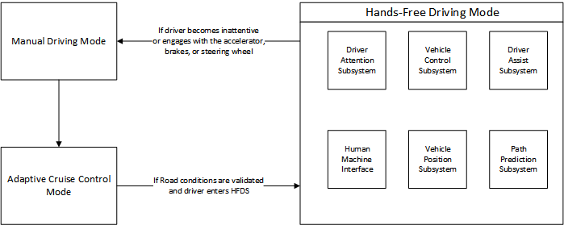

Figure 1: Diagram representing the transitions between the possible driving modes of the vehicle.

The driver is only able to enable the system on highways which have sufficient LiDAR mapping data. The driver must first activate adaptive cruise control, at which point the system will evaluate if the road conditions will allow for the operation of the Hands-Free Driving System. Safe road conditions require all of the following to be met: adequate LiDAR mappings of the road, all sensors fully operational, fully visible lane markings, fair weather conditions, and full driver attention. If all the conditions are met, an icon within the dashboard will be illuminated, indicating the driver may activate the HFDS mode.

**2.2 Product Functions**

The major functions the software will perform are as follows:

1. Validate road conditions to ensure the safe operation of the Hands-Free Driving system.
2. Adjust the vehicle speed relative to other vehicles by maintaining an adaptive cruise control state.
3. Maintain the vehicle position within the current lane by monitoring the current position and trajectory of the vehicle based on input from the sensors.
4. Monitor the driver’s attention by tracking the head and eye movement of the driver while the system is enabled.
5. Provide warnings and alerts to the driver if the system determines the driver is inattentive.

A high-level goal diagram illustrating the relationship of these functions to the goals of the system can be seen below in figure 2.

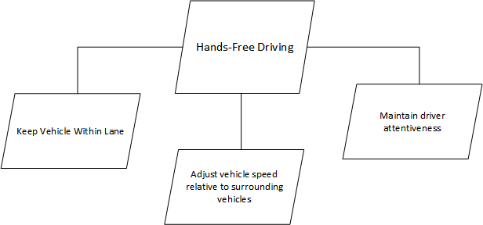

Figure 2: High-level goal diagram illustrating relations between product functions and system goals.

**2.3 User Characteristics**

The users of the system are drivers of GM vehicles in which the hands-free driving system is included. These drivers may have a wide range of backgrounds with regards to driving skill level, vehicle knowledge, and understanding of the system. It should be expected that users are able to operate the system with minimal knowledge of the vehicle or the Hands-Free Driving system.

**2.4 Constraints**

Due to the safety-critical nature of the Hands-Free Driving system, there are numerous safety-critical components, and corresponding constraints. If the system detects a failure in any of the subsystems or sensors, it will relinquish control to the driver [5]. Hardware and sensor redundancies must be in place to provide time for the driver to become re-engaged with the vehicle if a problem occurs [5]. If the system detects that the driver is not engaged, it will trigger three alerts of increasing intensity. If after the third warning, the driver has not returned attention to the vehicle, the system will initiate braking, come to a stop, and turn on the vehicle's hazard lights. In order to properly detect the attentiveness of the driver, the camera system must operate properly under all lighting conditions.

**2.5 Assumptions and Dependencies**

There are several assumptions that have been made about the system while designing the requirements. It is assumed that the lane detection and adaptive cruise control systems are pre-existing features. It is also assumed that Adequate LiDAR mapping of highways has been captured [5]. Proper operation of the HFDS relies on these assumptions being fulfilled.

**2.6 Apportioning of Requirements**

Based on discussions with the customer, it has been determined that several features fall outside the scope of this project, but may be included in later releases of the system. This project will not include any functionality for the system to steer to avoid obstacles such as other vehicles, potholes, or other debris. The HFDS will only steer to keep the vehicle within its lane markings.

**3 Specific Requirements**

1. The system must automatically control the steering, braking, and acceleration of the vehicle while in hands-free mode.
   1. The system will disengage if the user adjusts the steering wheel, braking, or accelerator.
   2. The system will detect, notify and give up control to user if any single point of failure is detected
2. Driver Assist System will validate road conditions, current trajectory, sensor input and predicted path
   1. If the path is determined safe, user can opt to enter hands-free mode and once engaged user can remove hands from the steering wheel
3. The system may only engage on highways that have been enabled by the Path Prediction System.
4. Driver must be alerted when they are entering/exiting hands-free mode
   1. Once the driver has entered hands-free mode, the vehicle will remain in adaptive cruise control state and will stay within the existing lane for the duration of the session
5. The system must be aware of surrounding vehicles and take appropriate action to prevent a collision with other vehicles.
   1. The system must maintain a safe distance between lead cars when in hands-free mode.
   2. The system must drive at a speed matched to other vehicles
6. The system will evaluate inaccuracies with the predicted and current path and take appropriate action
7. The Driver Attention System will monitor the driver’s eyes and head movements to ensure attentiveness.
   1. If the driver is inattentive, warnings will occur until the final warning which vibrates the driver
      1. If after the final warning, no corrective action is taken by the driver, the vehicle must disengage the hands-free mode and if needed, come to a stop.
8. If the system determines that there is a failure to maintain hands-free driving, a notification warning will be issued to the driver that they must retake control of the vehicle.
   1. If the final warning is unsuccessful, the system will abort hands-free mode and come to a stop if needed
9. Camera monitoring should work in all lighting conditions
10. Hardware and sensor redundancies must be in place to ensure safe operation and provide time for the driver to become re-engaged with the vehicle if a problem occurs

Cybersecurity requirements:

1. Systems and components that govern safety must be protected from harmful attacks, unauthorized access, damage, or anything else that might interfere with safety functions
2. The system will detect, notify and give up control to the user if any single point of failure or input anomaly is detected

Threat vectors (pathways for attacks):

1. Physical access
2. Short-range wireless access

Threat actors (types)

* Cybercriminals - motivated by money and will attack if they can profit from it [4]
* Hacktivists - desire to undermine reputations or destabilize operations by vandalizing or other means [4]
* State-sponsored attackers - motivated to collect information over the long-term and can be difficult to identify [4]
* Insider threats - Actors that can be malicious or could be good people who are misleading. These can be prevented by training and user behavior analytics [4]

There are several cybersecurity vulnerabilities within our system. Below is a description of each, with a plan for how to detect, prevent, and mitigate each vulnerability to prevent unsafe operation of the HFDS.

Physical Access:

**OBD-II/CAN** - Provides access to the car’s internal CAN buses. These can be interfaced with easily using commercial diagnostic tools or using inexpensive microcontrollers/PC interfacing devices [3]. If the adversary has direct access to these tools and the vehicle, they could reprogram the car’s ECUs or begin reverse engineering CAN bus signals/messages so they could reproduce them later. Mitigation for potential OBD-II cybersecurity vulnerabilities include physically separating critical CAN buses away from the diagnostics bus so they cannot be accessed easily. This would also protect against a denial of service attack from reaching the critical CAN bus lines and blocking message transmission. Additionally, diagnostic tools should be strictly controlled as to minimize the potential for them to reach malicious actors. Adding in an encryption/verification and obfuscation layer on top of CAN bus commands while they are in transit should make reverse engineering much more difficult. One way to detect unauthorized CAN bus attacks would be to constantly check for safe conditions, vehicle position and current trajectory even while executing vehicle control commands. If at any time the system detects anomalies between the control messages and the safety of the situation then it should safely fall back to the user.

**External camera** - In our system, external cameras on the vehicle are used to validate the real-world position of the system. A malicious actor could place something in front of or in the line of sight of the camera that the system may misinterpret as an obstacle, causing the system to behave unexpectedly. In order to mitigate this, we will use multiple sources to validate the position of the vehicle and of the surrounding environment. If there is any ambiguity, the system will give control back to the user.

Short-range wireless attacks:

**GPS** - The GPS system provided by the United States Air Force allows for any GPS receiver to receive geolocation and time information if it can receive the GPS signals [2]. These signals are often weak, though, and can easily be jammed by inexpensive jamming devices that emit radio noise. In order to mitigate this, we will use multiple sources to validate the position of the vehicle and of the surrounding environment. If there is any ambiguity, the system will give control back to the user.

**LiDAR** - The LiDAR sensor used in our system allows for the detection of objects and environmental features using a laser and light sensor. These sensors could be vulnerable to a denial of service attack by blinding the LiDAR sensor with another laser or other light. This DOS attack could cause the system to behave unexpectedly and enable the system when the environment is unsafe. In order to mitigate this, we will use multiple sources to validate the position of the vehicle and of the surrounding environment. If there is any ambiguity, the system will give control back to the user.

**4 Modeling Requirements**

This section includes UML models depicting the elements of the system in a domain model, the possible states of the system in a state diagram, the sequence of events during operation of the system in sequence diagrams, and the possible uses of the system in a use case diagram. A data dictionary is included to provide further detail on the domain model, and use case descriptions are provided to provide clarification on the use case diagram.

Figure 3 illustrates the initialization of the hands-free driving mode where it evaluates sensor/environmental conditions and notifies the user of the hands-free driving mode status (enabled/disabled).

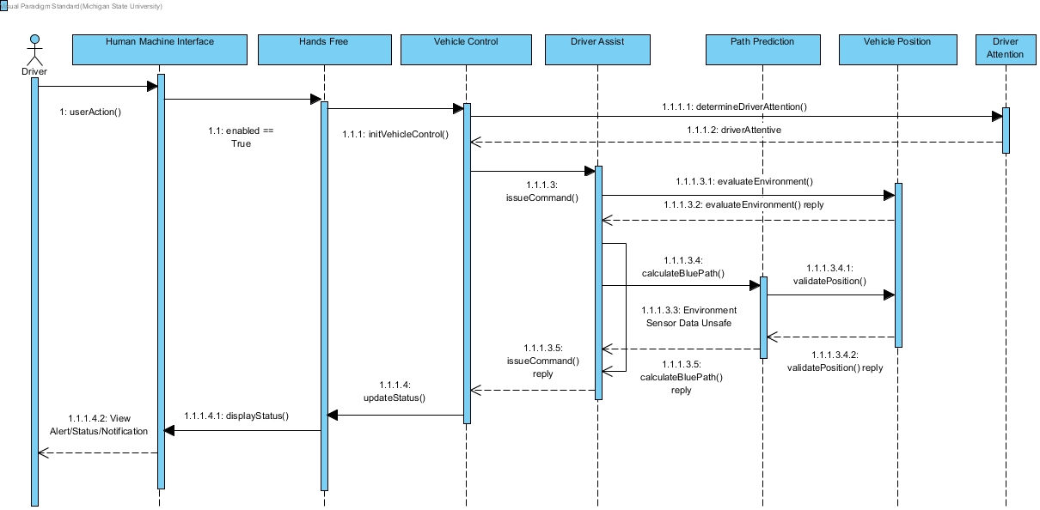

Figure 3: Sequence Diagram for evaluating conditions and notification

Figure 4 illustrates the core functions of the hands-free driving system while the hands-free driving mode is enabled. The system evaluates sensor/environmental conditions and appropriately controls the vehicle. 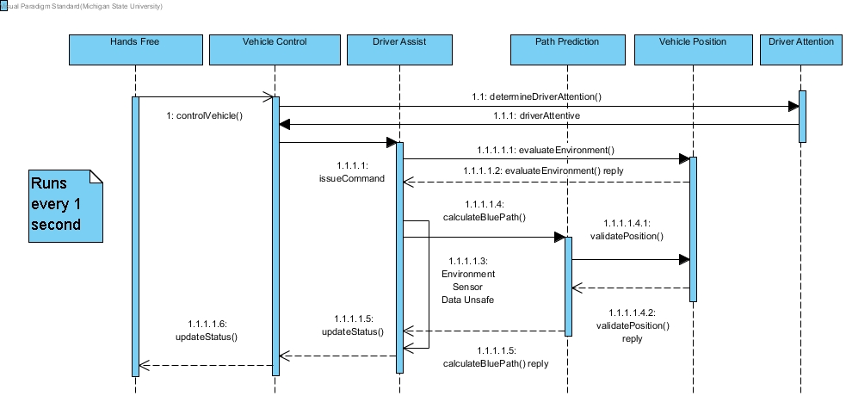

Figure 4: Sequence Diagram for core functions of HFDS

Figure 5 describes the system response to an inattentive driver. It will alert the user visually and with an audio cue for the first two times and then will safely navigate the vehicle to a stop. The user will also receive a notification about this process.

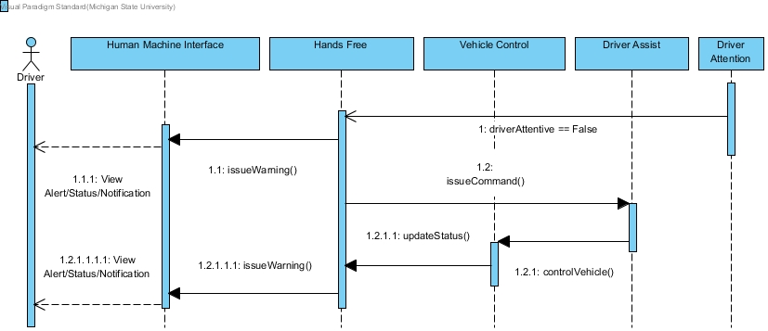

Figure 5: Sequence Diagram for inattentive driver

Figure 6 shows the response to a user action that will disable the system. If the driver engages with the vehicle's accelerator, brakes, or steering wheel, a disable message will be propagated throughout the core subsystems and the user will be notified when the system is disabled.

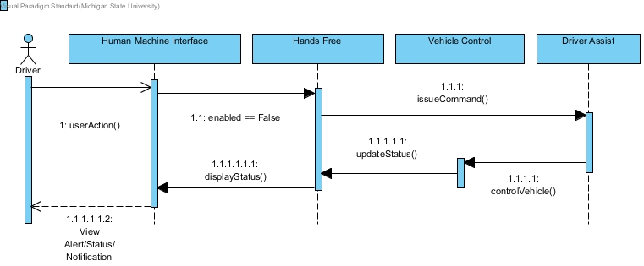

Figure 6: Sequence Diagram for disabling system

Figure 7 is the state diagram for the complete Hands-Free Driving System. This specifies the behavior of the entire system including the subsystems.

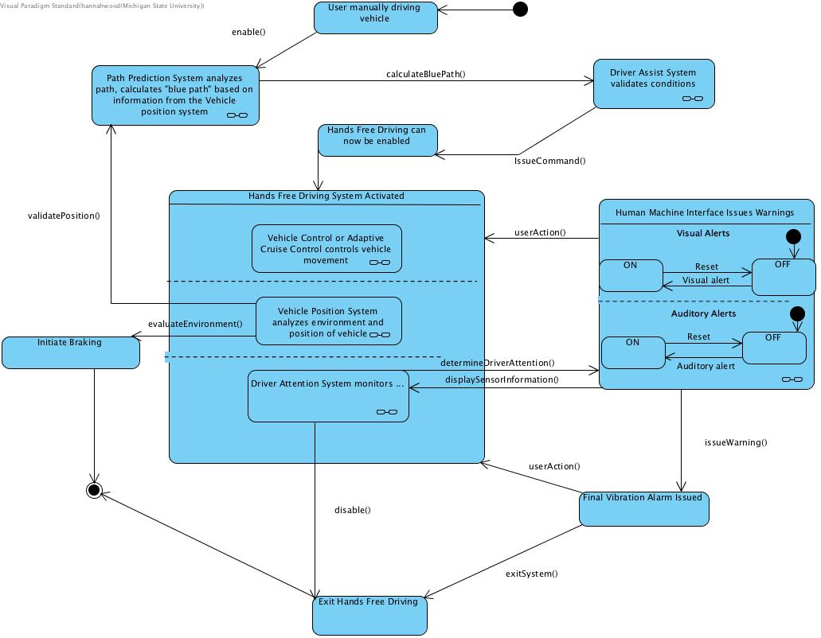

Figure 7: State Diagram for HFDS

Figure 8 illustrates the behavior of the vehicle control system within the hands-free driving system. The vehicle control system is a key component of the hands-free driving system since it controls all the vehicles movements

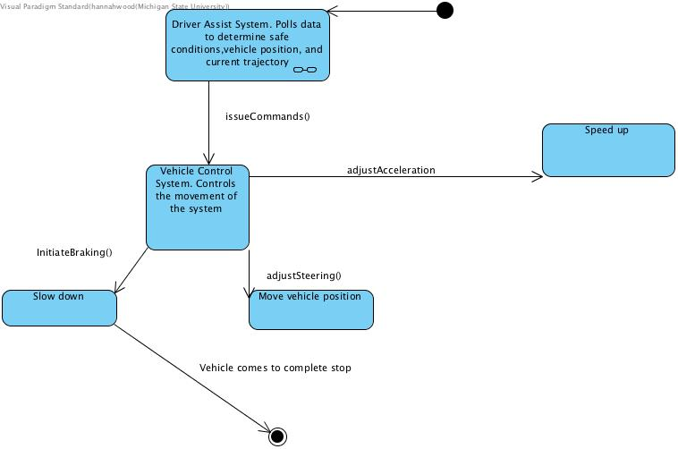

Figure 8: State diagram for the vehicle control subsystem

Figure 9 is a domain model which describes the key elements of the HFDS system and the relationships between those elements.

Figure 9: Domain model for HFDS

Below is a data dictionary further describing each class in the domain model along with its attributes and operations as well as how each class relates to the other elements of the system.

|  |  |  |
| --- | --- | --- |
| **Element Name** | | **Description** |
| Accelerator | | Controls the acceleration of the vehicle. |
| Attributes |  |  |
| Operations |  |  |
| Relationships | Can be controlled by the Vehicle Control System based on commands sent from the Driver Assists System. Can also be controlled outside of the system by the driver. If the driver uses the accelerator, the Hands-Free system will disengage. | |
| UML Extensions |  | |

|  |  |  |
| --- | --- | --- |
| **Element Name** | | **Description** |
| Brakes | | Control the braking of the vehicle |
| Attributes |  |  |
| Operations |  |  |
| Relationships | Can be controlled by either the Vehicle Control System, or outside of the system by the driver. If the driver uses the brakes, the Hands-Free system will disengage. | |
| UML Extensions |  | |

|  |  |  |
| --- | --- | --- |
| **Element Name** | | **Description** |
| Camera | | Camera sensor that allows for vision-based capabilities for various systems |
| Attributes |  |  |
| Operations |  |  |
| Relationships | Allows the Vehicle Position System to see surrounding objects and environment. Also communicates with the Driver Attention System to allow sensing of driver attentiveness. There can be more than one camera with both of these systems. | |
| UML Extensions |  | |

|  |  |  |
| --- | --- | --- |
| **Element Name** | | **Description** |
| Driver Attention Monitor | | Monitors Driver attention and determines if the system is safe to continue operating. |
| Attributes | driverAttentive : boolean | Tracks whether the driver is currently paying attention to the road. |
| Operations | determineDriverAttention | Determines whether the driver is currently paying attention based on data from the camera. |
| Relationships | The Driver Attention System contains one or multiple cameras in order to monitor the driver.  It also sends data to and warnings to the Human Machine Interface System in order to alert the driver. | |
| UML Extensions |  | |

|  |  |  |
| --- | --- | --- |
| **Element Name** | | **Description** |
| Driver Assist | | Assists driver in evaluating all sensor data and choosing how to operate the vehicle. |
| Attributes |  |  |
| Operations | issueCommand | Issues a command to the vehicle control subsystem based on input from the path prediction or vehicle position subsystems. |
| Relationships | The Driver Assist System receives sensor data from the Vehicle Position System and trajectory from the Path Prediction System. Once the vehicle status is determined and the correct route is chosen, this information is sent to the Vehicle Control System in order to make the vehicle move. | |
| UML Extensions |  | |

|  |  |  |
| --- | --- | --- |
| **Element Name** | | **Description** |
| GPS Receiver | | GPS Receiver sensor for location data. |
| Attributes |  |  |
| Operations |  |  |
| Relationships | Communicates with the Vehicle Position System by sending current location data. | |
| UML Extensions |  | |

|  |  |  |
| --- | --- | --- |
| **Element Name** | | **Description** |
| Hands Free | | Parent system of the subsystems that make up the hands-free driving system. |
| Attributes | Enabled : boolean | Is the system enabled or disabled |
| Operations | updateStatus | Updates the current state of the hands-free system based on input from other subsystems. |
|  | enable | Enables the Hands-Free driving system |
|  | disable | Disables the Hands-Free driving system |
| Relationships | Has aggregate relationship with all the following subsystems:  Driver attention, Driver assist, Vehicle control, Path Prediction, Vehicle Position, and Human Machine Interface. | |
| UML Extensions |  | |

|  |  |  |
| --- | --- | --- |
| **Element Name** | | **Description** |
| Human Machine Interface | | Accepts user inputs, displays sensor information and displays warnings. |
| Attributes |  |  |
| Operations | displaySensorInformation | Display information about the sensors to the user on the dashboard. |
|  | issueWarning | Issues a warning to the driver to indicate that they need to return their attention to the vehicle or that they must regain control of the vehicle. |
|  | displayStatus | Displays the current status of the hands-free system. |
|  | userAction | Defines any user actions of the system such as enabling or disabling the systems. |
|  | exitSystem | Exits the Hands-Free driving mode if the user presses the disable button or engages with the vehicle controls. |
| Relationships | The Human Machine Interface System communicates with the Driver Attention System to display warnings and sensor information. It also communicates with the driver to accept user inputs and pass those to other systems. | |
| UML Extensions |  | |

|  |  |  |
| --- | --- | --- |
| **Element Name** | | **Description** |
| Path Prediction | | Calculates the projected path for navigation. |
| Attributes |  |  |
| Operations | calculateBluePath | Calculates the blue path of the vehicle based on its current position and trajectory. |
| Relationships | The Path Prediction System communicates with Vehicle Position System to grab information on the vehicles outside environment to calculate a path to drive. | |
| UML Extensions |  | |

|  |  |  |
| --- | --- | --- |
| **Element Name** | | **Description** |
| Radar | | Radar sensor for object detection |
| Attributes |  |  |
| Operations |  |  |
| Relationships | Communicates with the Vehicle Position System by sending information about nearby objects. | |
| UML Extensions |  | |

|  |  |  |
| --- | --- | --- |
| **Element Name** | | **Description** |
| Steering Wheel | | Controls the steering of the vehicle. |
| Attributes |  |  |
| Operations |  |  |
| Relationships | Can be controlled by the Vehicle Control System based on commands sent from the Driver Assists System. Can also be controlled outside of the system by the driver. If the driver moves the steering wheel, the Hands-Free System will disengage. | |
| UML Extensions |  | |

|  |  |  |
| --- | --- | --- |
| **Element Name** | **Description** | |
| Vehicle Position | Processes sensor data and validates the vehicles position in the real-world. | |
| Attributes |  |  |
| Operations | validatePosition | Validates the position of the vehicle using data from the Camera, Radar, and GPS Receiver sensors. |
|  | evaluateEnvironment | Evaluates the vehicles environment using the camera and radar sensors to decide if the environmental conditions are safe for hands-free driving. |
| Relationships | The Vehicle Position System communicates with the Camera, Radar and GPS Receiver systems to get data for processing. Additionally, it communicates with the Driver Assist System by sending data to it so it can validate vehicle position, road conditions, current trajectory and sensor input. | |
| UML Extensions |  | |

|  |  |  |
| --- | --- | --- |
| **Element Name** | | **Description** |
| Vehicle Control | | Receives vehicle control messages and performs actions for hands-free driving such as steering, braking or adjusting acceleration. |
| Attributes | desiredSpeed | The desired speed of the vehicle based on input from the Driver Assist subsystem. |
| Operations | initiateBraking | Initiates braking on the vehicle based on commands sent from the Driver Assist subsystem. |
|  | adjustSteering | Adjust the steering of the vehicle according to commands sent from the Driver Assist subsystem, which are based on the blue path created in the path prediction subsystem. |
|  | adjustAcceleration | Adjusts the speed of the vehicle to keep it at/near the desired speed. |
|  | initVehicleControl | Initializes control of the vehicle by the hands-free system when the hands-free mode is enabled by the driver. |
|  | controlVehicle | Controls the vehicle by acting on the braking, steering, and acceleration systems as appropriate based on commands from other subsystems. |
|  | enable | Enables the vehicle control system when the Hands-Free driving system has been enabled. |
| Relationships | The Vehicle Control System receives commands from the Driver Assist System and initiates braking, steering or acceleration actions to the brakes, steering wheel or accelerator. | |
| UML Extensions |  | |

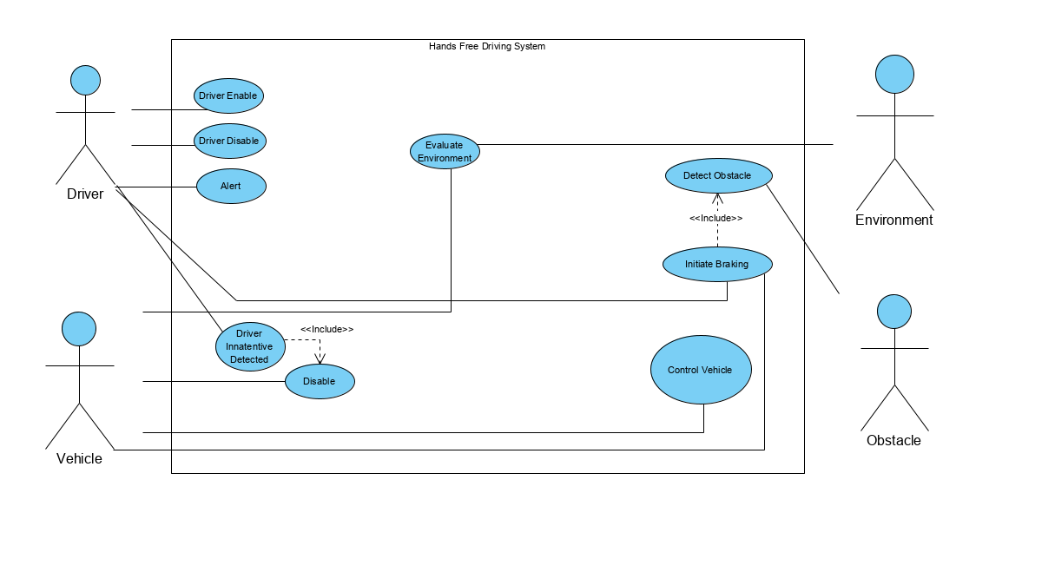Figure 10 is a use case model that illustrates the functionality of the hands-free driving system along with different use cases including obstacle detection, driver inattentiveness and the driver manually enabling and disabling.

Figure 10: Use case diagram for HDFS

The following are use case descriptions that further explain the use cases shown in figure 10.

|  |  |
| --- | --- |
| *Use case:* | Driver Disable |
| *Actors:* | Driver |
| *Description:* | The driver can disable the system by steering, throttle, or braking. The system immediately disengages and alerts the user. The system must be enabled in order to disable. Similarly, if the system decides that the conditions are not valid for the system to be engaged due to a fault or error, it can disable itself in this way as well. |
| *Type:* | Primary, Essential |
| *Includes:* | N/A |
| *Extends:* | N/A |
| *Cross-refs:* | 15 |
| *Use cases:* | Driver Enable |

|  |  |
| --- | --- |
| *Use case:* | Driver Enable |
| *Actors:* | Driver |
| *Description:* | The driver can enable the system by pressing a button. The system will then check that the user is on a highway with a valid blue path and that the system is valid to engage and is safe. |
| *Type:* | Primary, Essential |
| *Includes:* | N/A |
| *Extends:* | N/A |
| *Cross-refs:* | *3, 4* |
| *Use cases:* | All |

|  |  |
| --- | --- |
| *Use case:* | Disable |
| *Actors:* | Car |
| *Description:* | The system observes that the driver is inattentive, disables itself, and initiates breaking along with turning blinkers on. |
| *Type:* | Primary, Essential |
| *Includes:* | System Fault, Driver Inattentive, Initiate Braking |
| *Extends:* | N/A |
| *Cross-refs:* | *4, 13, 16* |
| *Use cases:* | System Fault, Driver Inattentive, Initiate Breaking, Driver Disable, Driver Enable |

|  |  |
| --- | --- |
| *Use case:* | Evaluate Environment |
| *Actors:* | Environment, vehicle |
| *Description:* | The system will evaluate the outside conditions, ensuring the vehicle is on a highway, and ensure that all the components within the system are working correctly. |
| *Type:* | Secondary, Essential |
| *Includes:* | N/A |
| *Extends:* | N/A |
| *Cross-refs:* | *2, 3, 4, 6, 8, 9, 10, 11, 16* |
| *Use cases:* | N/A |

|  |  |
| --- | --- |
| *Use case:* | Detect Obstacle |
| *Actors:* | Obstacle |
| *Description:* | The system will observe the outside environment to detect any potential obstacles and alert the user and if necessary, initiate braking. |
| *Type:* | Secondary, Essential |
| *Includes:* | Initiate Braking |
| *Extends:* | N/A |
| *Cross-refs:* | *6, 7, 9* |
| *Use cases:* | Initiate Braking |

|  |  |
| --- | --- |
| *Use case:* | Initiate Braking |
| *Actors:* | Obstacle |
| *Description:* | When an obstacle is detected, or the driver is deemed inattentive (see Driver Inattentive Detected) by the system it will invoke braking of the vehicle. No notification is given. |
| *Type:* | Secondary, Essential |
| *Includes:* | Detect obstacle, driver inattentive |
| *Extends:* | N/A |
| *Cross-refs:* | *6, 7, 9, 10, 13, 15,* |
| *Use cases:* | Detect Obstacle |

|  |  |
| --- | --- |
| *Use case:* | Control Vehicle |
| *Actors:* | Vehicle |
| *Description:* | While the system is enabled it will control the speed and steering of the vehicle. At this point, the system is in full control of the vehicle, and the driver does not need to be in control any longer. The driver does however still need to be attentive to the system. |
| *Type:* | Primary and essential |
| *Includes:* | N/A |
| *Extends:* | N/A |
| *Cross-refs:* | *1, 3, 6, 7, 8, 9, 10* |
| *Use cases:* | N/A |

|  |  |
| --- | --- |
| *Use case:* | Alert |
| *Actors:* | Driver |
| *Description:* | If the system cannot be active due to environmental conditions or the event in which the driver is inactive, the system will alert the driver to bring their attention to relevant information. There are alerts such as lights on the steering wheel or auditory alerts in order to encourage the driver to be attentive. Seat vibrations are also an alert given. A green light is shown on the steering wheel to alert the driver that the system is on, and it will be blue while it is in manual driving mode. |
| *Type:* | Primary |
| *Includes:* | N/A |
| *Extends:* | N/A |
| *Cross-refs:* | *5, 12, 14, 16* |
| *Use cases:* | Auditory Alert, Visual Alert, Vibration Alert, System Status |

|  |  |
| --- | --- |
| *Use case:* | Driver Inattentive Detected |
| *Actors:* | Driver |
| *Description:* | The system using its Driver Attention subsystem composed of cameras monitoring the driver’s head determines that the driver is inattentive. At first a flashing green, then red light is shown on the steering wheel. A prompt will then be played over voice announcing the driver needs to take control immediately. If the driver still does not take control, the vehicle will come to a stop while remaining in its lane and turn the hazard lights on. |
| *Type:* | Primary, Essential |
| *Includes:* | Disable |
| *Extends:* | N/A |
| *Cross-refs:* | *12, 13* |
| *Use cases:* | Disable, Initiate Braking |

**5     Prototype**

The prototype we have produced demonstrates key hands-free system driving functionality. The prototype allows a user to simulate various driving scenarios that the system would encounter while in use on an enabled highway. These scenarios include the original ones outlined in the requirements document.

1. System fully operational - User activates system on a supported highway and issues warnings with the driver attention system.
2. System failure - System encounters a fault and must relinquish control to the driver.
3. Driver inattentive - driver becomes permanently disengaged with the vehicle and has all warnings issued to them before coming to a stop.
4. Driver override - The driver takes control of the vehicle from the HDFS system.

**5.1        How to Run Prototype**

A computer or mobile device with a screen width of ~1000 pixels, has a web browser installed and has a keyboard are the hardware requirements for utilizing the software. JavaScript must be enabled for the application to function. The application has been tested with Google Chrome, Mozilla Firefox, and Apple Safari. Desktop and laptop computers are preferred as they provide a more immersive experience. The user can interact with the simulation through key bindings listed within the directions.

Link to prototype:

<https://www.cse.msu.edu/~sulfaroa/CSE-435-HFDS/prototypev2>

**5.2        Sample Scenarios**

One scenario that is included within the prototype is when the system is engaged, and the driver is deemed inattentive. The system will issue warnings to the driver to re-engage with the system.

In the demo, while the system is engaged there is a duration that is allowed for the system to operate on its own without driver input or attention. When the system detects that the driver is either not attentive for an extended period or has not interacted with some component of the car, the vehicle will issue a series of warnings of increasing intensities. First, there will be auditory and visual alerts to try and gain the driver’s attention. If the driver is still not responsive, then the system will issue a final warning where it introduces seat vibrations to the driver in an attempt to get them to re-engage.

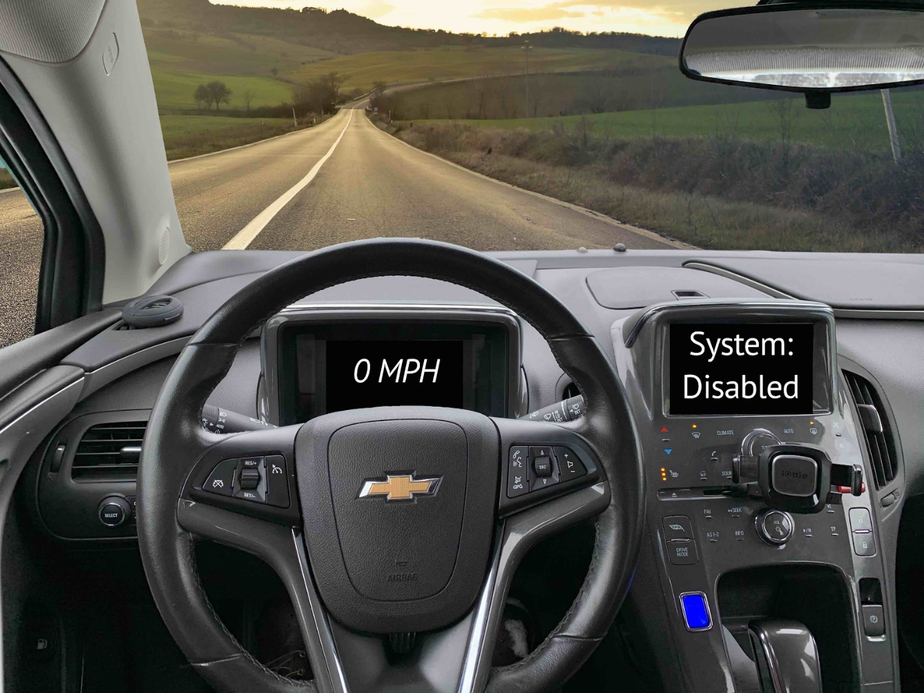

Figure 11: Alpha Version of PrototypeV1 Interface

The simulation itself updates based on user keystrokes on the page. Operating instructions and scenarios covered can be found on the [prototype page](https://www.cse.msu.edu/~sulfaroa/CSE-435-HFDS/prototypev2/).

**6     References**

[1] O. Cameron, “An Introduction to LiDAR: The Key Self-Driving Car Sensor,” Voyage, May 2017

[2] H. Shin, D. Kim, Y. Kwon, and Y. Kim, “Illusion and Dazzle: Adversarial Optical Channel

Exploits against Lidars for Automotive Applications,” 2017

[3] [S. Checkoway, D. McCoy, B. Kantor, D. Anderson, H. Shacham, and S. Savage,](http://www.autosec.org/pubs/cars-usenixsec2011.pdf)

[“Comprehensive Experimental Analyses of Automotive Attack Surfaces,” San Diego,](http://www.autosec.org/pubs/cars-usenixsec2011.pdf)

[California, 2011.](http://www.autosec.org/pubs/cars-usenixsec2011.pdf)

[4] “Proactive Defense: Understanding the 4 Main Threat Actor Types,” Recorded Future,

05-Mar-2019. [Online]. Available: <https://www.recordedfuture.com/threat-actor-types/>.

 [Accessed: 18-Nov-2019].

[5] A. Davenport, “Hands-Free Driving System (HFDS)”, 2019. [Online]. Available:

[https://www.cse.msu.edu/~cse435/Projects/F2019/ProjectDescriptions/2019-HFDS-GM-](https://www.cse.msu.edu/~cse435/Projects/F2019/ProjectDescriptions/2019-HFDS-GM-Davenport.pdf)

[Davenport.pdf](https://www.cse.msu.edu/~cse435/Projects/F2019/ProjectDescriptions/2019-HFDS-GM-Davenport.pdf)

**7     Point of Contact**

For further information regarding this document and project, please contact **Prof. Betty H.C. Cheng** at Michigan State University (chengb at msu.edu). All materials in this document have been sanitized for proprietary data. The students and the instructor gratefully acknowledge the participation of our industrial collaborators.